2nd Annual “I AM ANUSARA” Fundraising Campaign
GLOBAL CELEBRATION OF GRATITUDE
March 21st – June 21st, 2019
Thank you for your interest in the 2nd annual “I Am Anusara” global fundraising campaign! This is a wonderful way to foster a unified community that inspires and supports all practitioners of Anusara yoga from local to global.

Why Participate in This Fundraising Campaign
The Anusara School of Hatha Yoga needs diverse revenue sources to be sustainable. License fees only provide about 25% of what the School needs to survive and thrive. In the same way our bodies need a variety of foods to ensure we get the proper amount of protein, vitamins, minerals and fats, the School needs a variety of funding sources.
Donations from teachers and others are an important part of that mix. This year they support:
- Professional development for aspiring and existing Anusara teachers
- Updating Anusara teaching manuals
- Marketing webinar series for teachers
- Promotion of your events
- Samavesha 2020 in Europe
- Strengthening our capacity for communications among our worldwide community
- Promotion of the Anusara brand worldwide
- Promotion of ASHY’s relationship with Yoga Vibes
- Pursuit of additional corporate sponsorships

How to Plan An “I Am Anusara” Fundraising Event
- You may organize a single class or all day including other practices i.e. Meditation, Ayurveda, Kirtan.
- You may decide the cost of your class, depending on your country’s usual prices.
- The class may be joined by other teachers.
- You may also donate the revenues of one or more regular classes or of a workshop that you were already planning on offering.
- You may share your event on ASHY’s new FB page: I am Anusara.

How To Make Your “I am Anusara” Donation
- Login to your MindBodyOnline ASHY account.
- If you have not done so previously or have forgotten your password, follow the instructions here
- Click on the “Online Store” tab, then “Donations-Registrations.”
- In the drop-down box, select “Donations”

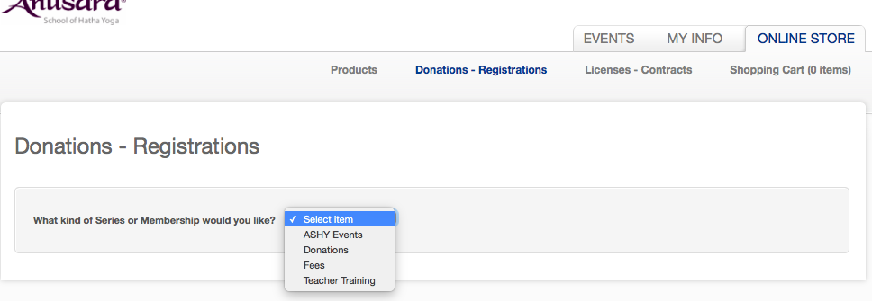
You will see a list of different dollar amounts:
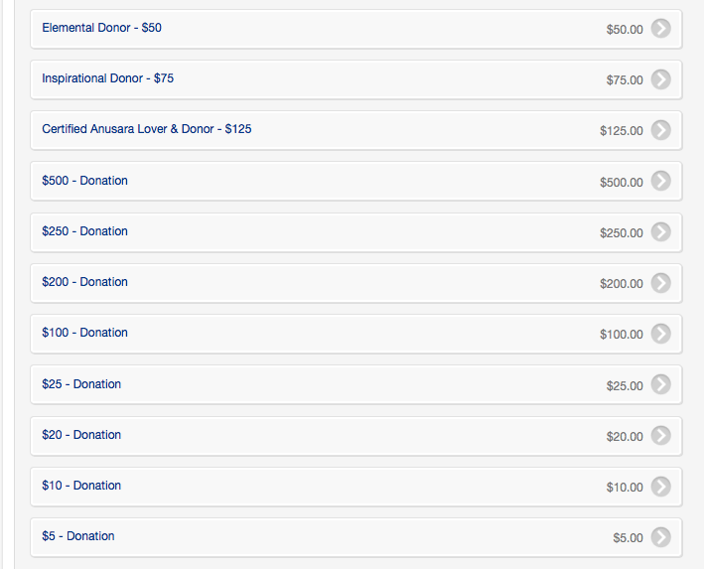

For example, if your donation is $170, you would follow these steps:
- Choose $100. Then you will see the shopping cart.

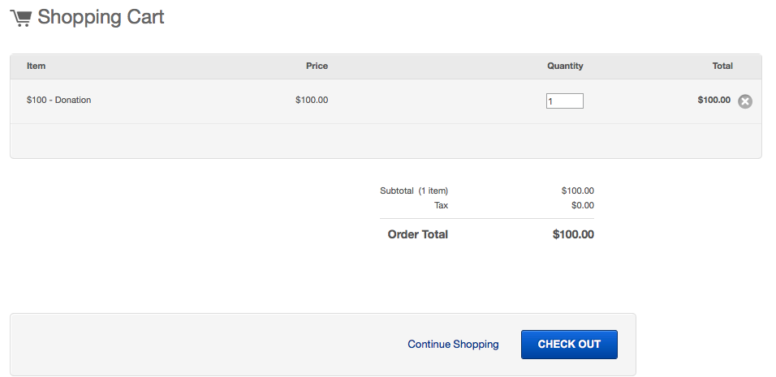
- Click on “Continue Shopping” and repeat the steps to get to the list of donation amounts. Now select $25 and make the Quantity “2”

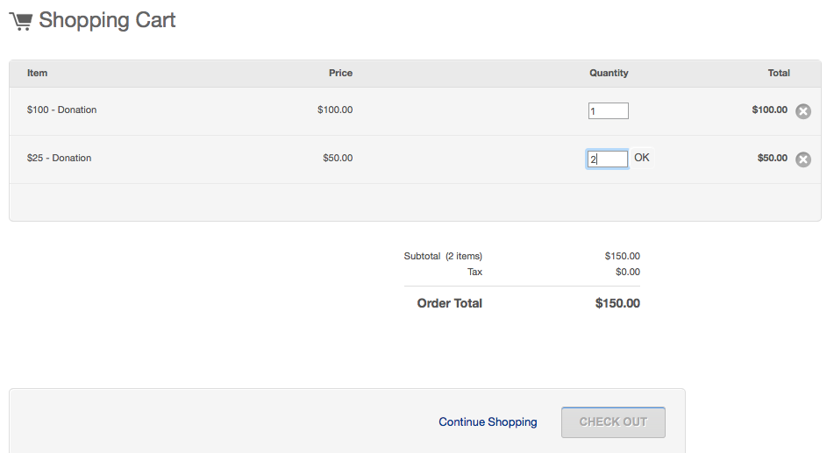3) Click on “Continue Shopping” and repeat the same steps get to the list of donation amounts. Now select $20.

- When you have selected the amount that totals your donation, click on the “Checkout” button. When your email address is displayed, you can proceed with the billing information.
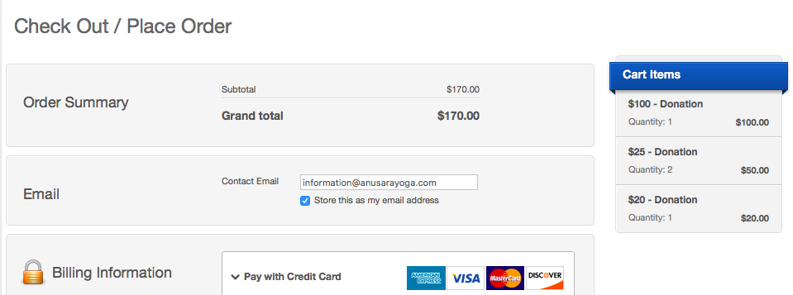

I am Anusara!
As licensed teachers, we ALL are Anusara!
The Anusara School of Hatha Yoga receives your donation with deep gratitude.

For additional information, please contact your Country Coordinator.

